TIP Upgrade (within Microsoft Teams) – 2020

The TIP upgrade has been developed within Microsoft Teams (Due to roll out in February 2020) and will be piloted by the Business Change team between January – March 2020.

Benefits;
- No File.
There is no hard file for the TIP in MS Teams. It’s built from a SharePoint list and added to MS Teams. However the list can be exported to excel and can be saved if you wish to do so.
This also means any number of people can add new and update tasks all at the same time!

- No file means, no saving.
It’s very quick to open and update. Smooth process of adding items and updating your tasks.

- Status of task (Traffic lights)
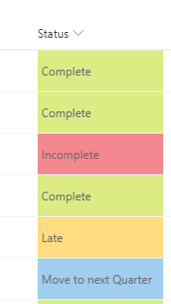
Set colours for the status of yours tasks in just two clicks! You can update the status to inform your manager once a task has been completed. Great visually.
(This list can be modified)

- Customise views
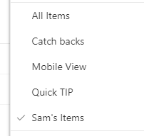
You can customise the view of the TIP from a managers, catch backs or your own perspective. Filter the list and save the view. You can also decide if you want the view to be shared with the rest of the team.
Eg. “Sam’s items” on the list shown is personal.
So when I go and look at the TIP myself, I can quickly
Select the “Sam’s items” view and focus on my tasks.

- Mobile compatible
You can download the Microsoft Teams app on your phone and view, add and update the TIP in live time. As it’s mobile compatible, it’s very easy to do.

- Side bar - focusing on the task
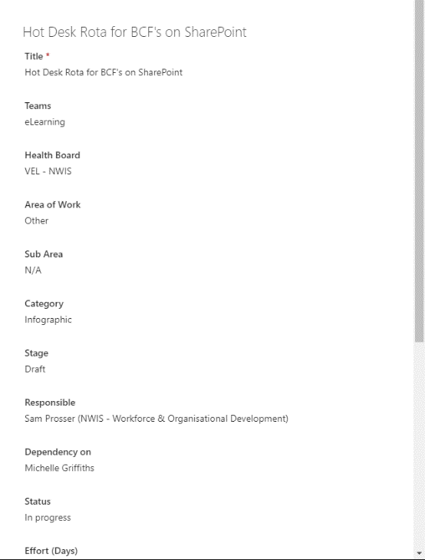
When updating or adding a new task to the current TIP, instead of having a huge list in front of you and amending different fields going across, this version gives you a separate side bar focusing on the one task you’re updating or adding.

  - Multiple Selections
On the current TIP you can only select one option from any drop down. In the upgrade you can now select multiple options eg. You can assign more than one person to a task.

