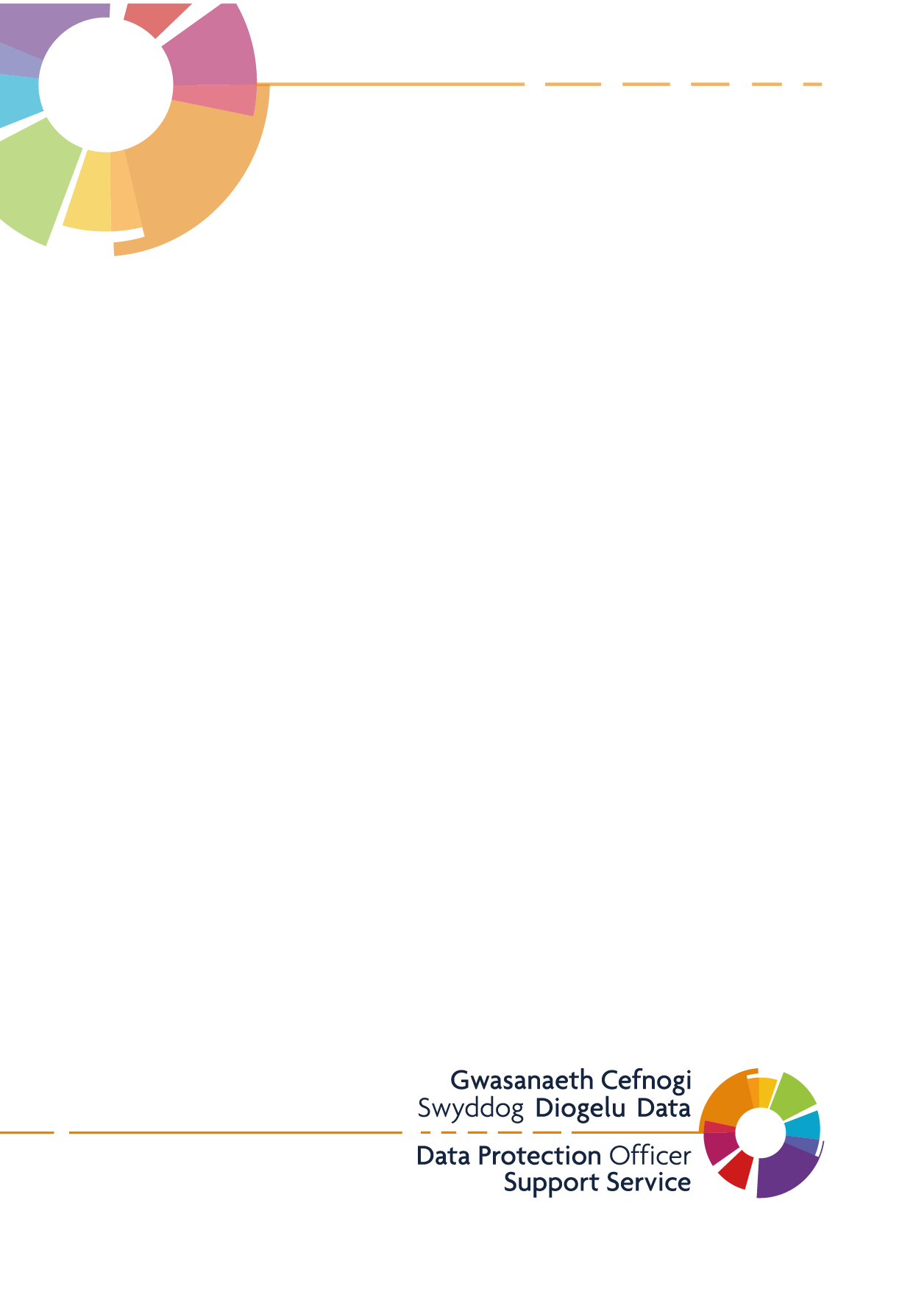
Personal Data Breach & Security Incident Procedure
Meddygfa Penygroes Surgery

Version: 1.1
Last Updated: 20/04/2021

Version: 1.1
Upd
Contents
1.0 Purpose and Scope 2
2.0 Responsibilities 2
3.0 Incident Reporting 3
4.0 Incident Investigation 3
4.1 Investigation procedures 3
4.2 Investigating the breach 4
4.3 Reporting a breach 6
4.4 Maintaining a record 6
5.0 Common Data Breaches 7

Purpose and Scope

This purpose of this procedure is to ensure that when Personal Data Breaches or Security Incidents occur, they are investigated in a timely and appropriate manner, the adverse consequences are kept to a minimum and mechanisms are set in place to help prevent a repetition or similar occurrences.
Data protection legislation defines a personal data breach as “a breach of security leading to the accidental or unlawful destruction, loss, alteration, unauthorised disclosure, or access to personal data transmitted, stored or otherwise processed”.
The three types of breaches defined in the Article 29 Working Party guidance are:
- Confidentiality - an unauthorised or accidental disclosure of, or access to, personal data
- Integrity - unauthorised or accidental alteration of personal data
- Availability - an accidental or unauthorised loss of access to, or destruction of, personal data
These are sometimes referred to as CIA. It is important to note that a personal data breach may include one or any combination of the above breach types.
When deciding whether to report a personal data breach, it is important to determine whether the breach poses a risk to a data subject(s) by considering the likelihood and severity of the risk to their rights and freedoms as a result of the breach.
Responsible individuals within the Practice must take a reasonable view about categorising and notifying based on the information available at the time; this may be revisited if additional information later comes to light.

Responsibilities

The Practice Manager – Wendy Currums /Senior Partner – Dr Gillian Ellis Williams /IG LEAD & Caldicott Guardian – Dr Jonathan Kinnear is to ensure there is a policy and procedures for the reporting and handling of security incidents within the Practice and how the policy/procedures are linked to the Practice disciplinary procedure.
The procedures must cover:
- Incident reporting procedures
- Key roles and responsibilities
- Procedures for containing, investigating and resolution of the incident
- Escalation / onwards reporting procedures (e.g. to the NHS Wales Network, Information Commissioner’s Office)
The Practice should also appoint the Practice Manager – Wendy Currums /Senior Partner – Dr Gillian Ellis Williams /IG LEAD & Caldicott Guardian – Dr Jonathan Kinnear who will be responsible for:
- Taking the primary role in the investigation of data protection and security breaches (e.g. dealing with confidentiality breaches, viruses, unauthorised access, systems failures).
- Commencing investigation of the incident, in accordance with the Practice’s Incident Investigation Procedure.
- Report all data protection and security breaches to the Lead Partner, Data Protection Officer and where appropriate to the Health Board.
- Assign the Incident a unique Incident Number and record the date of receipt upon receiving a correctly completed Part A of the Security Incident Form.
- After due consideration of the details of the Incident, they will complete Part B of the Security Incident Form.
- Regularly review trends in security incidents and recommend any additional control measures that are considered necessary as a result of the incident investigations. The Practice Manager – Wendy Currums /Senior Partner – Dr Gillian Ellis Williams /IG LEAD & Caldicott Guardian – Dr Jonathan Kinnear and the Systems Manager must be consulted regarding the implementation of extra controls.

Incident Reporting

The reporting of security incidents is the responsibility of all staff and this procedure should be followed for any type of security related incident experienced within the Practice. The Practice Manager – Wendy Currums /Senior Partner – Dr Gillian Ellis Williams /IG LEAD & Caldicott Guardian – Dr Jonathan Kinnear will appoint a Security Manager for the Practice.
Any member of staff identifying a breach or potential breach of security should alert the appointed Security Manager immediately. If the designated individual is unavailable the incident should be reported to the Practice Manager – Wendy Currums /Senior Partner – Dr Gillian Ellis Williams /IG LEAD & Caldicott Guardian – Dr Jonathan Kinnear

4.0 Incident Investigation
Incident investigation should be carried out by the appointed individual, in conjunction with the Practice Management Team and System Manager where appropriate and necessary.

4.1 Investigation procedures
Upon discovering, or receiving notification of, a potential data or security breach it is important to follow a standard and repeatable procedure in order to avoid mistakes and ensure vital evidence is not destroyed during the course of the investigation.
Due to the variability of the types of data or security breaches that may be encountered it is not possible to give precise steps for dealing with every eventuality. The following steps are recommended as a basis for the development of Practice procedures.

4.2 Investigating the breach/incident
The following steps will be followed by the appointed individual when investigating the circumstance of a breach/incident:
- Review the reported incident. Document the incident details, facts, tip-offs, clues, and any other useful information for constant reference.

- Consider:
  - How did the incident come to light?
  - Who reported it?
  - How reliable/credible are they?
  - What indications are there that something is wrong?

Remember: It is not unknown for someone with ‘first-hand knowledge’ of an incident to provide a different explanation of the chain of events when their initial panic has subsided. Careful checking of the situation and the facts is both prudent and wise.

- Establish the extent of the incident, what other systems and staff are involved and in which areas of the Practice? Does it involve individuals outside of the Practice?

- Consider the legal position – will you be breaching any person’s rights under the Human Rights Act, UK GDPR, the Data Protection Act 2018, and/or any other applicable legislation? Seek specialist advice if in doubt, before you act.

- Next you should determine whether you need to report the incident or breach to other NHS organisations, or to external other bodies such as the Information Commissioner’s Office, Police or Welsh Government, before going any further. Failure to notify the appropriate body could leave you or your Practice liable. If it is not clear whether a reportable incident has occurred at this stage, you should keep it in mind and report it as soon as it becomes apparent.

- Research the background as much as possible. For example: What devices/systems/processes are involved? Who is involved – are they appropriately trained and/or technically competent?

- Establish who you need to speak to in order to get a clear picture of the situation.

- Ask open questions (who, how, what, when, etc.) and avoid leading questions (e.g. by mentioning names or blaming people). Make sure you do not breach any person’s rights under the Human Rights Act, UK GDPR, the Data Protection Act 2018, and other legislation(s) during your investigation.

- If it is possible to consult other trusted members of staff about the incident, without alerting any potential suspects, do so discretely and make them aware of the need for secrecy and not jumping to conclusions.

- Make a record of all conversations and information received.

- Look for logical and non-malicious explanations for the chain of events before considering deliberate acts. Rule out the obvious before you investigate the improbable.

- Assess the impact to the Practice. Establish whether the systems involved are vital to the running of the Practice. If so you may have to investigate outside of normal working hours, depending on whether the issue requires immediate attention (e.g. a virus infection).

- Rank the severity/priority of the incident to ensure that commensurate and appropriate action is taken. Consider issues such as the consequence s of breaches of patient confidentiality, bad publicity, and legal sanctions.

- If the incident is the result of hacking, malware or unauthorised access to the Practice system’s or network, it should be raised with the Service Desk. It is important for the Service Desk to recognise the potential severity of the incident, and categorise as such, not just for the Practice but for the wider NHS Wales Network. So it is advised that any calls logged are followed up and the criticality of the incident is emphasised.

- Liaise with law enforcement if appropriate. Most Police regions have specialised units (usually called High-Tech Crime Units, Computer Examination Units or Technical Support Units) that can provide advice and assistance for the more serious cases.

- Make sure you have the right training and tools to carry out the investigation process.

The precise steps to be taken to investigate any incident or breach will vary dependent on the nature of the incident, e.g. a physical security issue may require discussions with the police over methods of entry, a systems related issue may require a detailed examination of the file system on a particular computer.

Note: The investigation of complex crimes is a specialised area of security, which may require physical and digital forensic examination skills and equipment in order to avoid contamination or destruction of potential evidence.

Where a crime is suspected the scene should not be tampered with and the Practice should seek specialist advice from the Police before undertaking a critical investigation. If the crime effects the ICT systems of the Practice, DHCW ICT Department should be notified immediately via ServicePoint.

4.3 Reporting a breach
Data protection legislation sets out a legal obligation to notify personal data breaches to the Information Commissioner’s Office (ICO), within 72 hours of you becoming aware of it, unless the breach is unlikely to result in a risk to the rights and freedoms of the data subject(s).
When you encounter a breach, you will therefore have a 72-hour window wherein it must be assessed and if necessary, reported to the Information Commissioner’s Office. A self-assessment tool is built into the DPO Support Service’s ‘Template – Personal Data Breach Report Form’, to assess whether any data or security breach is reportable to the Information Commissioner’s Office.
The DPO Support Service will also liaise with the ICO on the Practice’s behalf, and help draft and advise on correspondence and responses to any of their questions following a report of a breach to them.
As a subscriber to the DPO Support Service, the Practice can receive advice and guidance regarding any data or security breaches by contacting DHCWGMPDPO@wales.nhs.uk.

4.4 Maintaining a record
For all breaches, whether they are deemed reportable or not, a record should be kept. A template Record of Incident’s is available on the DPO Support Service’s website. Keeping an up to date record is a necessity of paving the way to compliance with the data protection legislation.
It allows you to identify any patterns and trends, target improvement areas, and staff training needs. Even if the breach is deemed not reportable to the ICO, the data subject still has the right to complain to either yourself or the ICO. If this happens, having an up-to-date record of the incident, including reasons why it was not reported is beneficial.
When completing this log, you should aim to be as detailed as possible. You should try to include as much of the following criteria as you can:
- Time and Date of the Incident.
- When did the Practice become aware of the incident?
- Was it reported to the ICO? Why?
- The details of the incident/breach.
- Were the data subject(s) notified? Why?
- Investigation details.
- ‘Lessons learnt’ and the any relevant actions taken.
- Any reference numbers if the DPO Support Service have provided advice.
- Any third parties that have been notified or consulted such as; the Local Healthboard, Primary Care, the System Suppliers, or Contractors.

5.0 Common Data Breaches
The following are the most common causes of data protection and security breaches that you are likely to encounter:

- Human Error: A large majority of breaches can be traced to human error. These are genuine mistakes that can happen to anyone, especially when concentration is waning.

- Training: Breaches may also occur if there is a lack of knowledge or training given to relevant staff. Staff should be routinely trained as good practice, so make sure you’re up to date!

- Malware: Some files that are downloaded from the internet may have malicious software packaged with them, these can steal data without your knowledge. You should always check with your ICT provider whether you can download third party software before doing so.

- Privilege Misuse: This can be linked back to lack of training, staff misusing their privileges can be a common cause for breaches. To help prevent this you should only limit staff access to what is necessary, and ensure that there is regular staff training, and auditing of access.

- Phishing: This is the fraudulent practice of sending e-mails purporting to be from reputable individuals or organisations, with the aim of influencing individuals to reveal personal data such as passwords or credit card details. If you receive an e-mail that looks illegitimate, report it to your ICT and E-mail provider!

- Hacking: This is the action of gaining unauthorised access to data in a system or computer. To help prevent against hacking you should ensure that your ICT security is regularly updated.

- Policy & Process: Without having a clearly defined Information Governance policy, and practices to go with it, you will be further exposed to potential data breaches. A template Information Governance Policy is available for adaptation on the DPO Support Service website.

