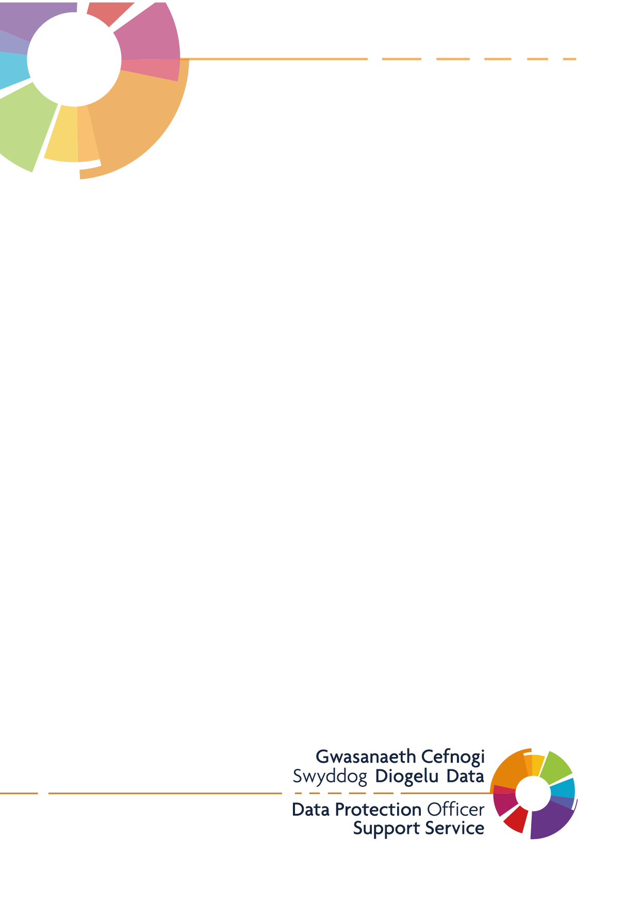
Transition and Transportation of Personal Identifiable Information (PII)
Meddygfa Penygroes Surgery
v2 – 26/04/21

Contents

1.0 Introduction 2
1.1. What is Personal Identifiable Information? 2
2.0 Background 2
3.0 Removal of Personal Data (from the Practice) 2
4.0 Transportation of Personal Data 3
4.1 Transporting Physical Records 3
4.2 Sending Physical Records Securely 3
4.2.1 Post 4
4.2.2 Courier 4
4.2.3 Hand delivery 4
4.2.4 Fax 4
4.3 Transporting Electronic Records or Devices 5
4.4 Transmission of Electronic Records 5
4.4.1 E-mail 5
4.4.2 Secure File Share 5
4.4.3 Text Messaging 6
5.0 Taking Information Home 6

Introduction
There are inherent risks associated with the requirement to take patient or person identifiable information away from the practice. This document has been developed with the aim of providing guidance for General Medical Practices.
This document aims to raise awareness amongst practice staff (clinicians and administration), ensuring they do not breach the requirements of the Data Protection Act 2018, UK GDPR, PECR or the Caldicott Report guidance. Additional guidance on protecting information is also available from the General Medical Committee website.

What is Personal Identifiable Information?
Patient or person identifiable information is information that can identify any individual by name, number or a combination of items (staff records would also be included under this definition), and exists in paper or electronic form.
Any information which can identify an individual must only be removed from the practice if there is a justified purpose for doing so. If there are any issues regarding these procedures they should be immediately discussed with the Practice Manager – Wendy Currums / Senior Partner-Dr Gillian Elis Williams or the Caldicott Guardian/ Lead GP – Dr Jonathan Kinnear.

Background
The Information Commissioners Office (ICO) states that “personal information, which is stored, transmitted or processed in information, communication and infrastructures should also be managed and protected in accordance with the organisation’s security policy and using best practice methodologies such as ISO27001.”
ISO27001: ‘Information can be vulnerable to unauthorised access, misuse or corruption during physical transport.’
Therefore, every effort must be made to safeguard this information for the protection of the data subject, the individual and for the practice itself.
These procedures aim to highlight and suggest ways of improving the security and confidentiality of transporting sensitive information, regardless of the medium to prevent data loss.

Removal of Personal Data (from the Practice)
If a member of staff is required to take patient or person identifiable information off site as part of their role, the Practice’s Caldicott Guardian must be informed along with the Practice Manager – Wendy Currums / Senior Partner-Dr Gillian Elis Williams or the Caldicott Guardian – Dr Jonathan Kinnear. A Risk Assessment Form must be completed by the member of staff in conjunction with the Practice Manager/Senior Partner/Lead GP. An assessment of the risks involved will then be carried out and recommendations may be made to the member of staff if appropriate.
Once the member of staff & Practice Manager/Senior Partner/Lead GP are satisfied that the procedures are workable and will comply with current policy, the Risk Assessment Form will be signed and approved by the Practice’s Caldicott Guardian. A copy will be kept by the Practice Manager/Senior Partner/Lead GP and a copy given to the member of staff.
If, as part of the role, a member of staff is regularly required to remove patient or person identifiable information, they must state this on the Risk Assessment Form and the authorisation will continue until such time as the termination of the current post or a change in role. However this will be subject to regular review by the Caldicott Guardian.
If the need to take patient or person identifiable information away from the practice is for an isolated reason, this should be stated on the Risk Assessment Form. If at any time in the future the need arises again, the same process will need to be repeated.

4.0 Transportation of Personal Data
Any information, including medical records, taken off site must be logged. This log should contain the date, details of information, reason for removal, where the information is being taken and estimated date of return. This is essential to ensure appropriate audit measures are in place and records can be traced at all times. A template log is available to be used HERE.

4.1 Transporting Physical Records
When transporting physical records, all records must be transported in a secure way by the use of locked boxes or locked briefcases, and should be kept with the member of staff at all times.
All records, including medical records transported within a vehicle should not be visible to the general public should be carried in a locked container and locked in the boot of the vehicle. When transporting multiple records, only the relevant record(s) should be taken into patient’s home/nursing home/other destination. All other records must be stored in a locked container in the locked boot of the vehicle. All due care must be taken to ensure that the record remains complete at all times and is returned in its entirety when no longer required.
Paper records should be returned to the Practice when no longer needed. These should be logged that they have been returned, signed and dated by the returning member of staff. When medical record summaries are provided to carry out ‘house’ calls, these should be handed back into the Practice to update the computer record and the paper summary should be securely destroyed.
Personal items such as diaries may contain confidential information that may include details of home visits. Staff members should be reminded to carry these securely at all times and should not include information that may identify or assist in the identification of a patient.

4.2 Sending Physical Records Securely
When you need to send a physical copy of the record there are a variety of methods to choose from, some examples of these are listed below. The security of the information is paramount when sending via these methods, and each transfer should be assessed individually. Different levels of personal data and special category or ‘sensitive personal data’ will factor into what method is chosen.

4.2.1 Post
This is the most common method of sending physical records from the Practice. This is the likely method for sending letters, such as appointment confirmations or reminders to Patients.
It may also be considered as a method for responding to Freedom of Information or Subject Access Requests. Care must be taken to ensure that any records sent via post are addressed correctly, and only contain information relevant to the intended recipient to avoid breaching the rights and freedoms of the data subject.
Safeguards to make this method secure are to use services such as ‘Recorded Delivery’ which enables the tracking of the record in transit, and only allows delivery with a valid signature from the recipient. Any records being sent should be packaged appropriately, in a sealed envelope or parcel, with the information inside concealed.

4.2.2 Courier
Using a courier service is similar to sending via post, but are typically used when sending larger volumes, or if the record needs to get from A to B quickly. You may wish to employ a courier service if you are sending records between Practice’s in your local area, or to an archiving/storage service.
As with postal delivery, you must ensure that any records sent via a courier are addressed to the correct individual or organisation, and only contain the correct information. For larger record transfers, it is advised to use record boxes, which can be sealed and labelled prior to the courier collecting from the Practice. These should normally be tracked much like a recorded delivery, where you can monitor their progress and be updated periodically whilst on route to their final destination.
When using a courier service, you should ensure that you have an agreed contract in place with them prior to sending any records.

4.2.3 Hand delivery
A member of Practice staff would deliver the records in person. This can be used for transferring records within a Practice or Cluster group, or dropping off at a Patient’s house via a house call if appropriate. The rules for transporting records above should be followed by the staff member at all times.

4.2.4 Fax
Some organisations still make use of fax machines to send records, although they are gradually being phased out. We recommend that fax machines are kept in a secure area, away from any public rooms such as the reception area. A procedure should be in place to ensure that the receiver of the fax is present, to ensure that any records sent are not left unattended at the machine.
This should be reflected on both sides; If you are sending documents, you should ensure to call ahead to make sure that the recipient is at the fax machine when they come through. If you are notified of a fax coming to your Practice, you should anticipate to be there when it is received.

4.3 Transporting Electronic Records or Devices
When transporting information stored electronically it must be considered that the information is confidential, and on a need to know basis. Patient or person identifiable information must not be stored on portable devices, such as a, CD, USB storage device or laptop unless it is absolutely essential. If it is deemed to be essential, then the device must be approved by the practice and must be encrypted.
Only the relevant files should be copied onto the device that is being used to transport the information, as It is easy to inadvertently copy entire folders particularly when synchronising with portable devices such as laptops, tablets or USB storage devices.
The devices should be kept in a secure carrying case or laptop bag and locked In the boot of your vehicle whilst in transit. They should be removed and taken with you when you arrive at the destination.

4.4 Transmission of Electronic Records
When you need to send an electronic copy of a record there are a variety of methods to choose from, some examples of these are listed below. The security of the information is paramount when sending via these methods, and each transfer should be assessed individually. Different levels of personal data and special category or ‘sensitive personal data’ will factor into what method is chosen. The intended recipients of the transfer must always be double checked before sending, as it is easy to add additional recipients accidentally.

4.4.1 E-mail
E-mail is the most common form of electronic transfer that you’ll encounter. It’s a quick and easy method of sending information to one or more recipients, however you need to consider what information you want to send and to who.
E-mail is commonly used as a method of engaging with Patient’s and other third parties for general communications, such as appointment bookings, receiving queries and delivering news and updates regarding the Practice (if it is compliant with PECR).
If you are sending large volumes of personal data, or even sensitive personal data, you may want to consider whether e-mail is the appropriate method of transfer. You should employ appropriate security mechanisms such as encryption, password protection, or make use of MoveIT to further enhance the security of the e-mail and the contents/attachments. NHS Wales e-mail comes equipped with Transport Layer Security, or TLS. This is a form of encryption that makes for a securer transfer to other TLS enabled organisations. A list of these can be found on the HOWIS website.

4.4.2 Secure File Share
Secure File Share is a service operated by NHS Wales Informatics Service that can be used to send information securely. It allows you to upload the data to a temporary hosting area, and send a secure link and password to the intended recipient. They will then be able to access and download the data for a limited period of time before it is automatically deleted. This service is available to Practices to use via the web portal. However a call must be submitted to Service Point with the reason for the use before you can use it.

4.4.3 Text Messaging
Texting is now viable way of communicating with Patients, however we do advise that these are kept very generic for situations such as appointment reminders and news or service updates. Any texting that the Practice utilises must again be compliant with PECR.
Practices have access to My Health Text, which can be used for appointment reminders, to support the seasonal flu processes, Quality and Outcomes Framework and chronic disease management purposes, where the Practice has appropriate consent.
(To register for My Health Text you will need to log a call with Primary Care Service Desk at: PrimaryCare.ServiceDesk@wales.nhs.uk)

5.0 Taking Information Home
It should be noted that any applicable practice security policies and procedures will apply wherever the information is located, and should be adhered to at all times. Staff must not take medical records or any confidential information home overnight, without prior authorisation and unless it is absolutely necessary.
If a staff member is required to take confidential information home for the day, a locked container and all other items containing confidential information including laptops, files and USBs; should be locked away in the home and not left in the car overnight.
Staff must ensure that the information is not accessible by any other members of the household (including family, friends, and neighbours) even if these people are employees of the same organisation.
Under no circumstances should any family member be allowed to access a laptop owned by the Practice. This will reduce the risk of accidental incidents including the loading of illegal software, inappropriate internet access or viewing of confidential, restricted information.
Information must not be emailed to, or recorded on, any home PC as there are numerous issues regarding IT security. If an employee needs to work at home they should always be provided with the relevant equipment (including secure remote access tokens if connecting to the network) and access permissions as agreed by the Practice.
Tablets and laptops should be connected to the network at least once a week to enable synchronisation and updated to ensure that all information recorded is updated to the main Practice network.

